A.A.GOVERNMENT ARTS COLLEGE, MUSIRI

**Affiliated To Bharathidasan University, Tiruchirappalli**

**NAAN MUDHALVAN PROJECT - III BSC MATHEMATICS**

**THE TABLEAU HR SCORECARD: MEASURING SUCCESS IN TALENT MANAGEMENT**

**SUBMITTED BY**

**TEAM ID: NM2023TMID08431**

**TEAM LEADER:**

**NAME: M.SANGEETHA**

**NMID: 5F8C6D353655E6ABD054929021642DE3**

**MEMBERS**:

**1. NAME:M.SOWNDHIRIYA**

**NMID: 90BD67752EF33F484C249779DC9C6828**

**2.NAME: S.SUJATHA**

**NMID:690ED585065E7F78F5F43AD776ADB196**

**3. NAME:A.THILAGAVATHI**

**NMID: 306E54086715CA4AFBD4AC9B20DD0F02**

**INTRODUCTION**

**OVER VIEW:**

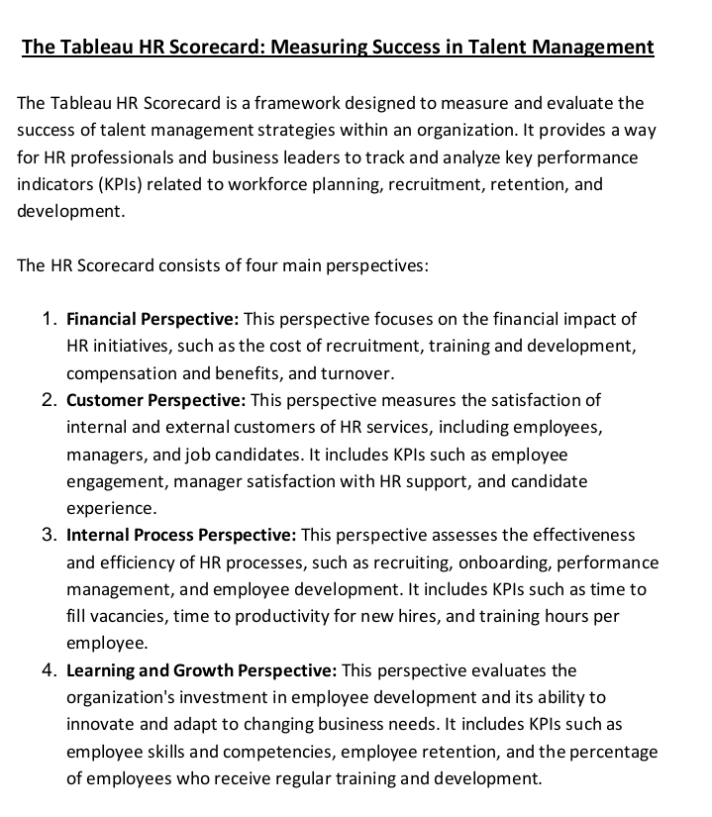

**PURPOSE:**



**TEACHNICAL ARCHITECTURE:**

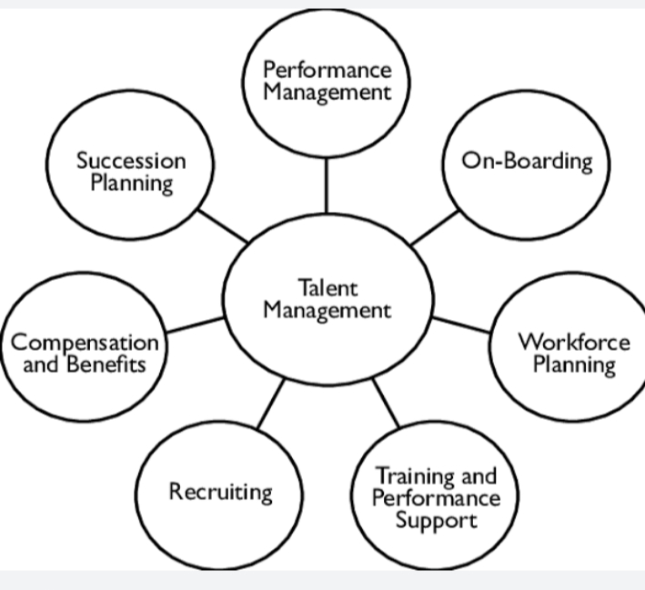

**PROBLEM DEFINITION & DESIGN THINKING:**

**Empathy Map:**

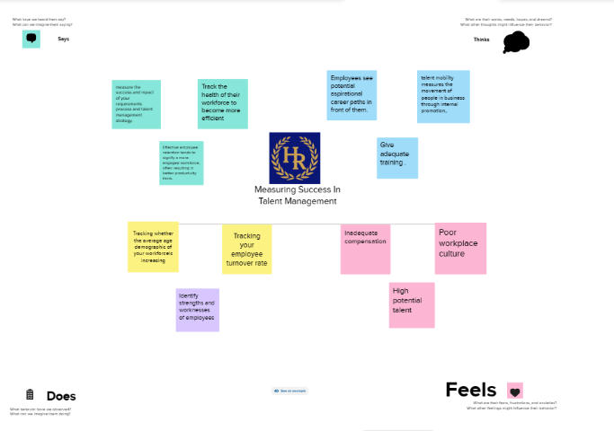

**Ideation & Brainstorming Map**

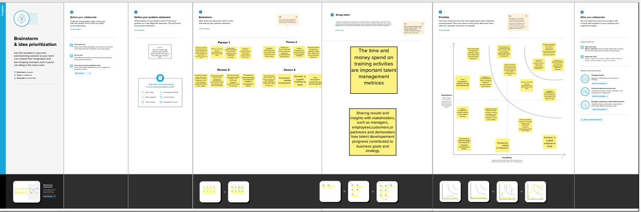

**RESULT**

**Dataset**

**XL File**

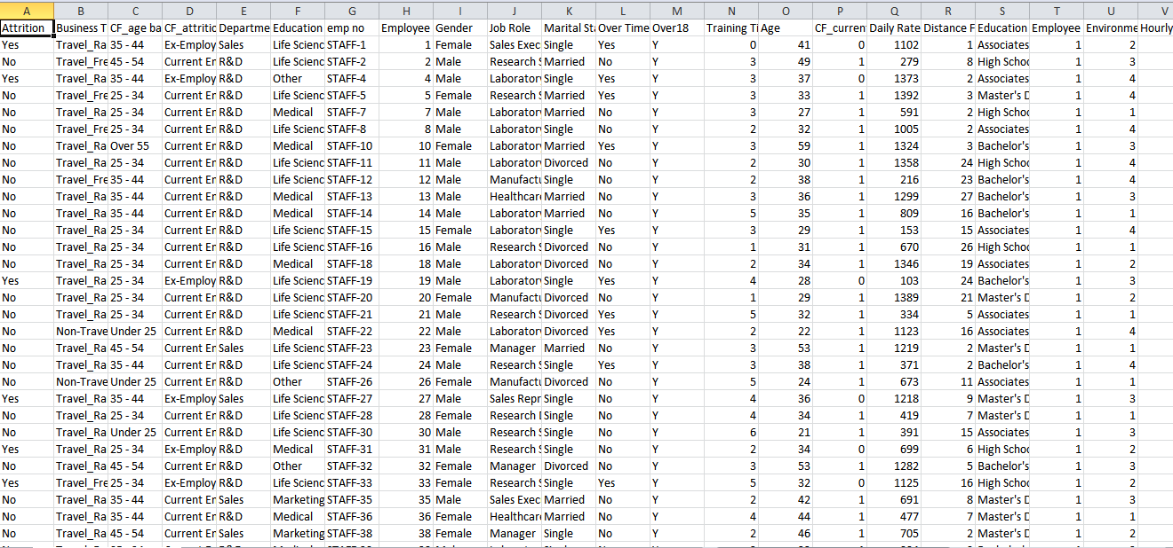

**CSV File**

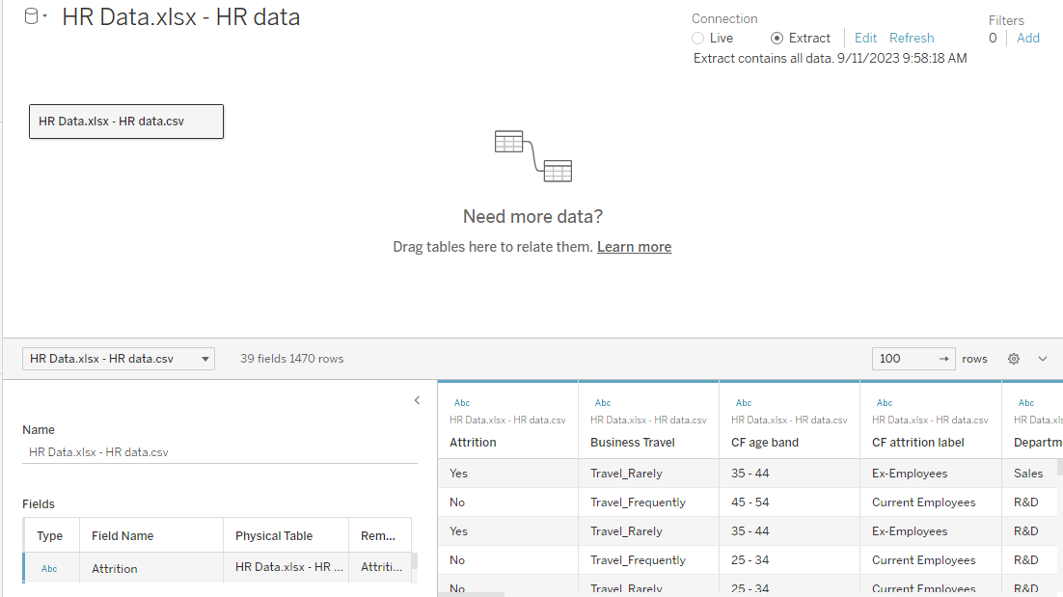

**Dash Board1:**

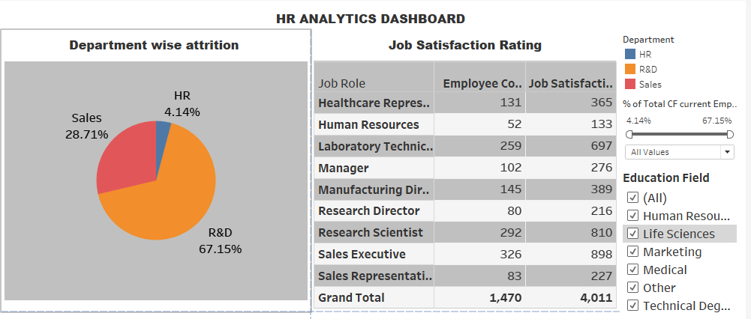

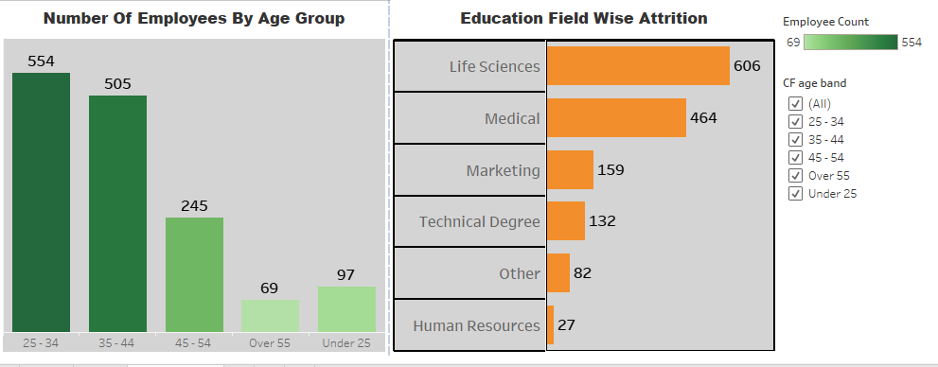

**Story1:**

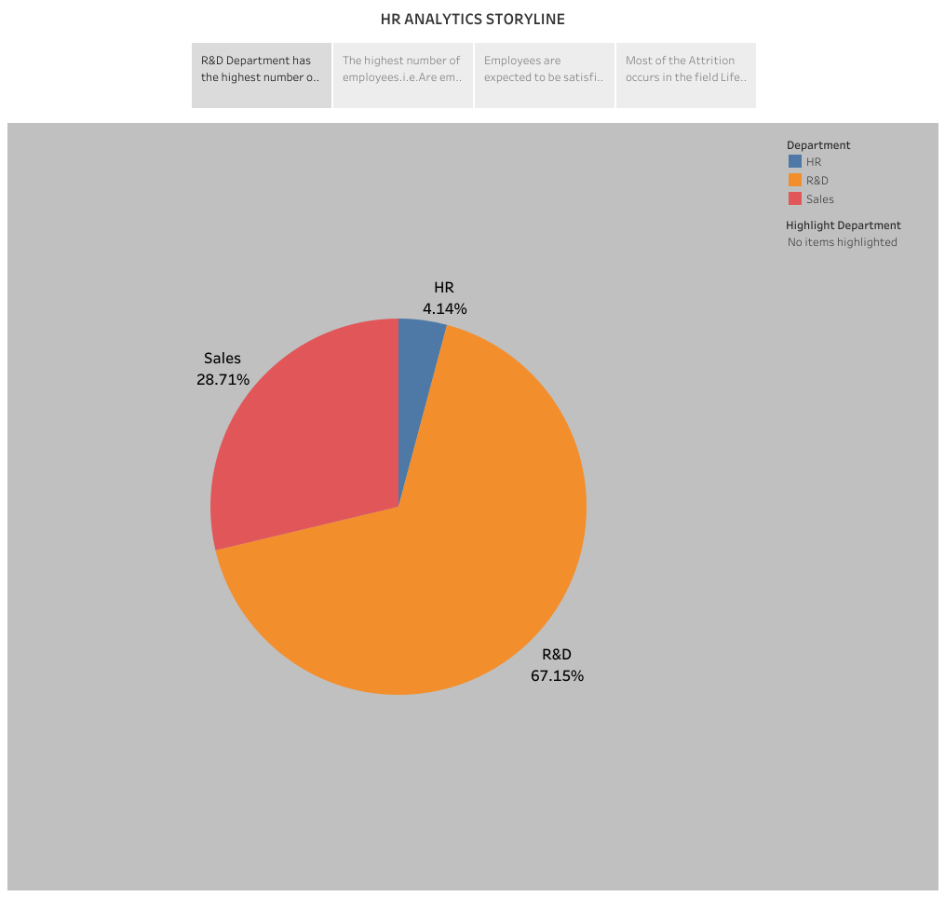

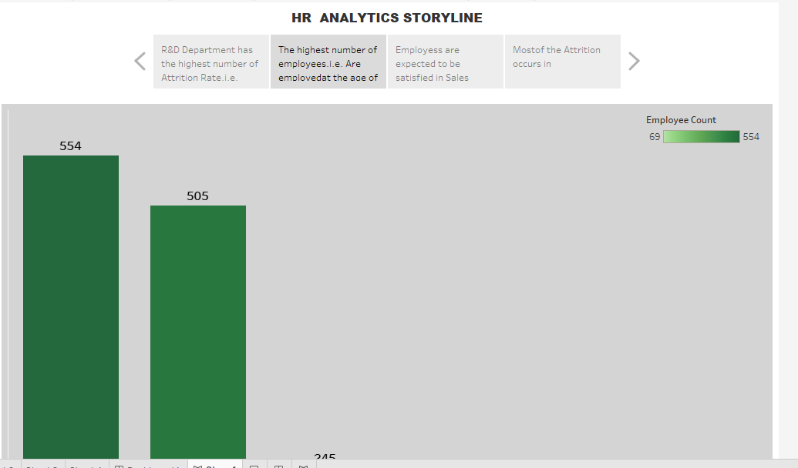

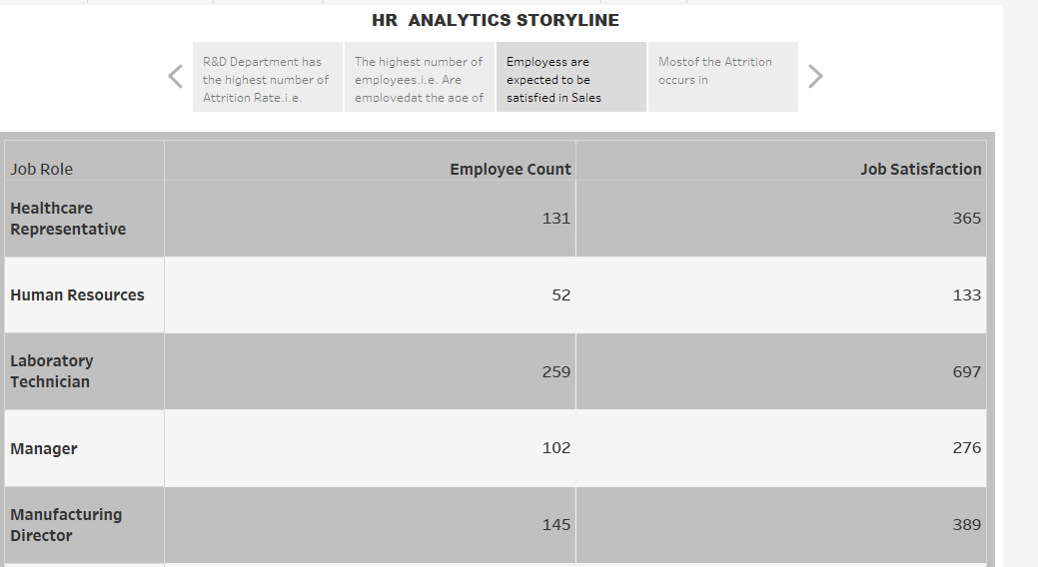

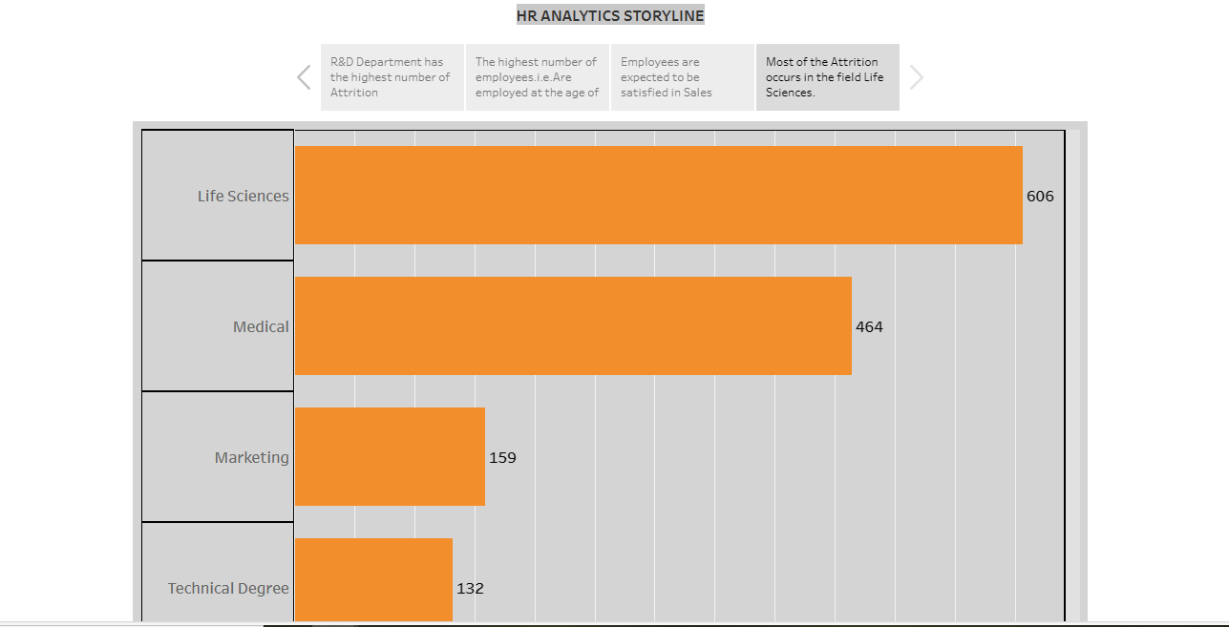

**DASH BOARD 2**

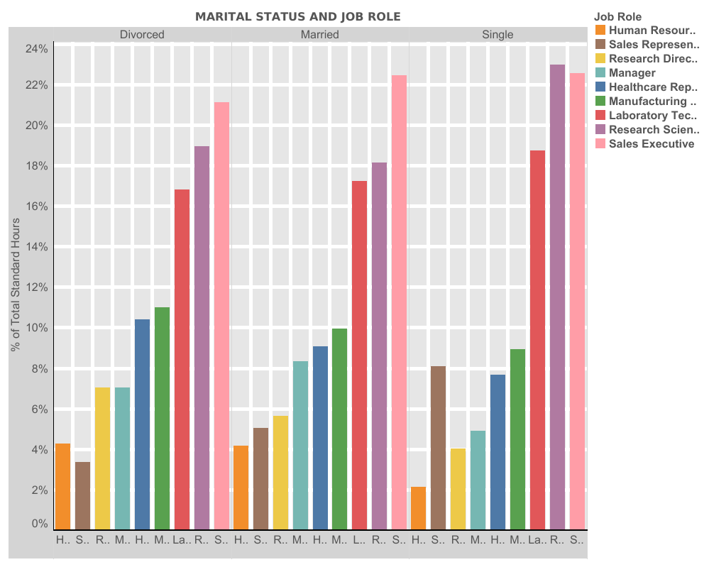

**DASH BOARD 3**

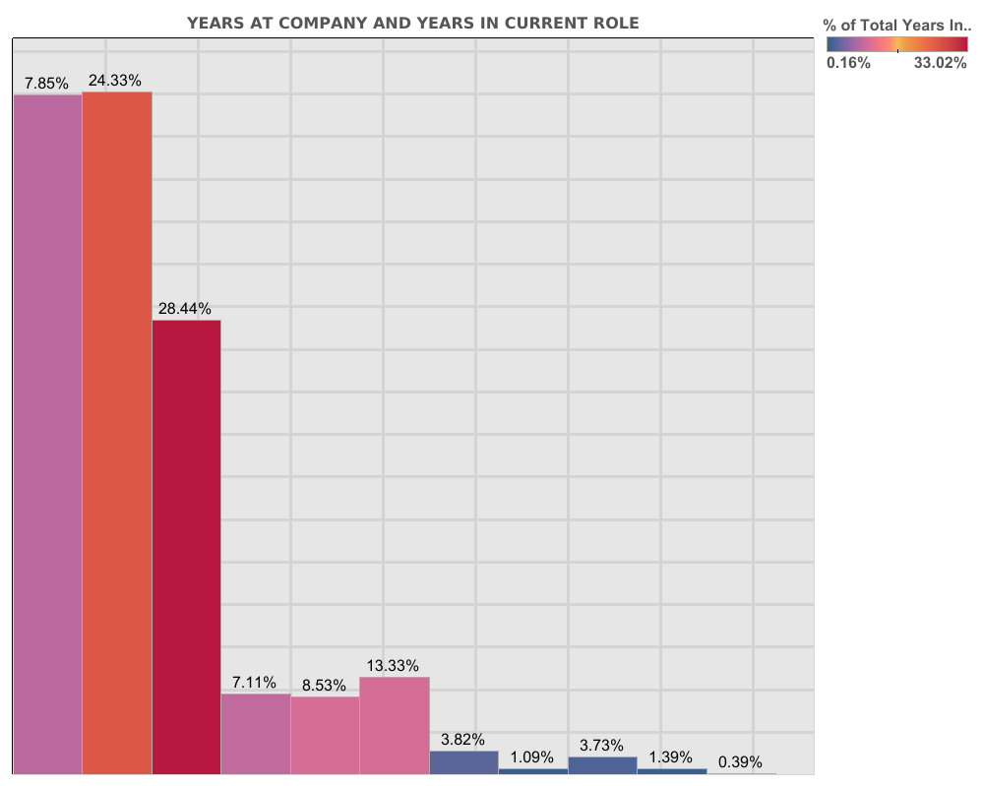

**DASH BOARD 4**

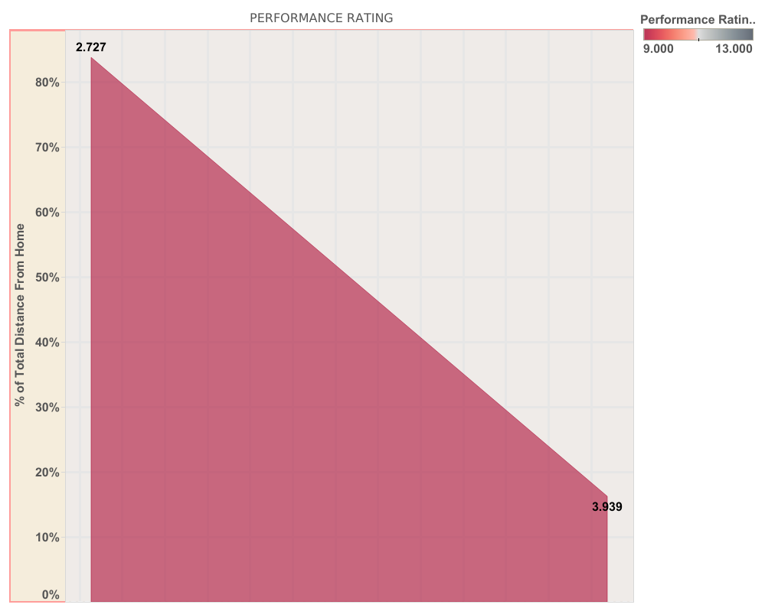

**STORY 2:**

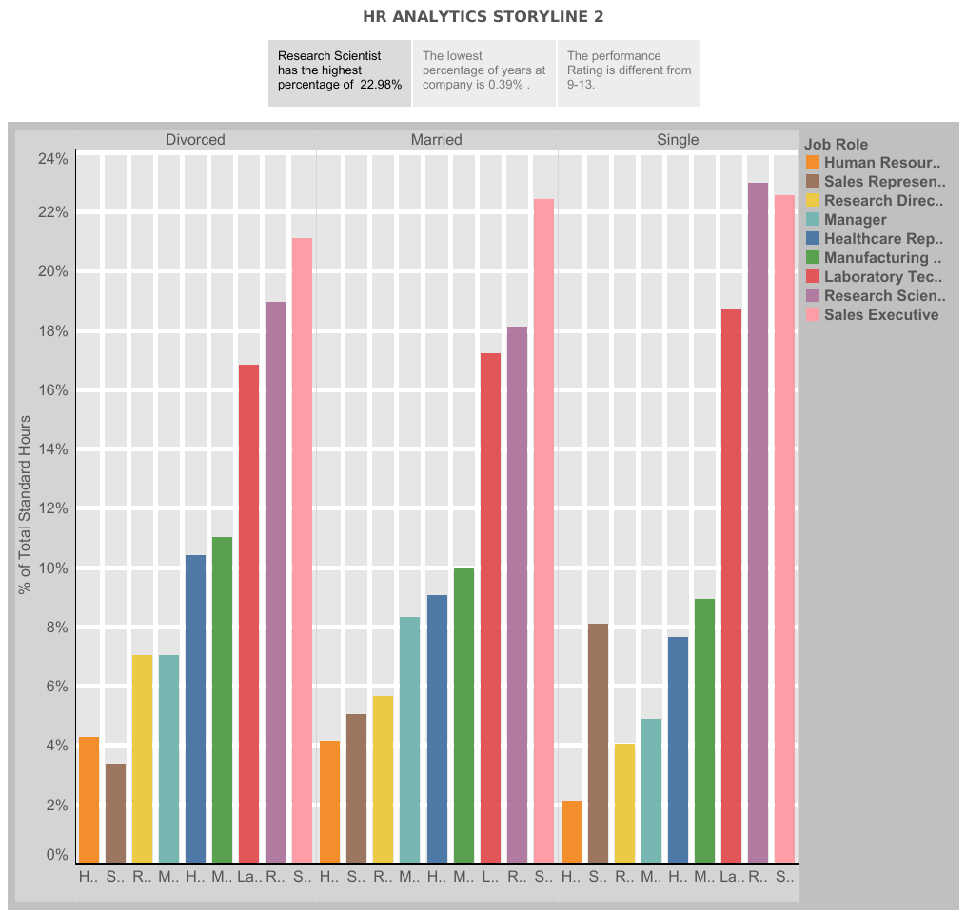

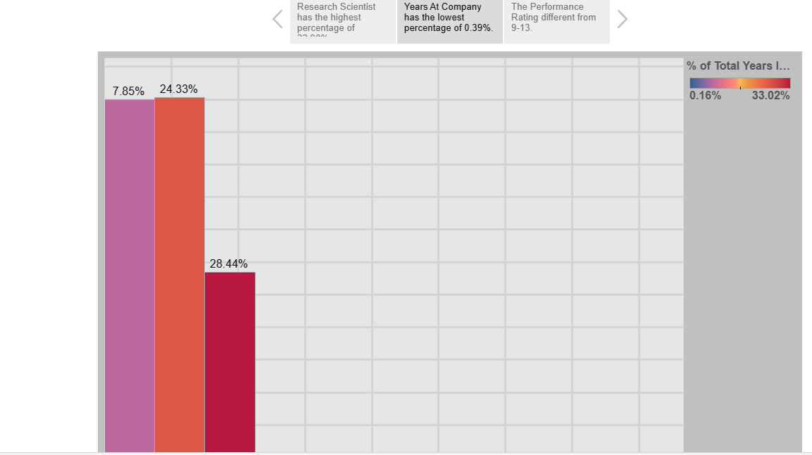

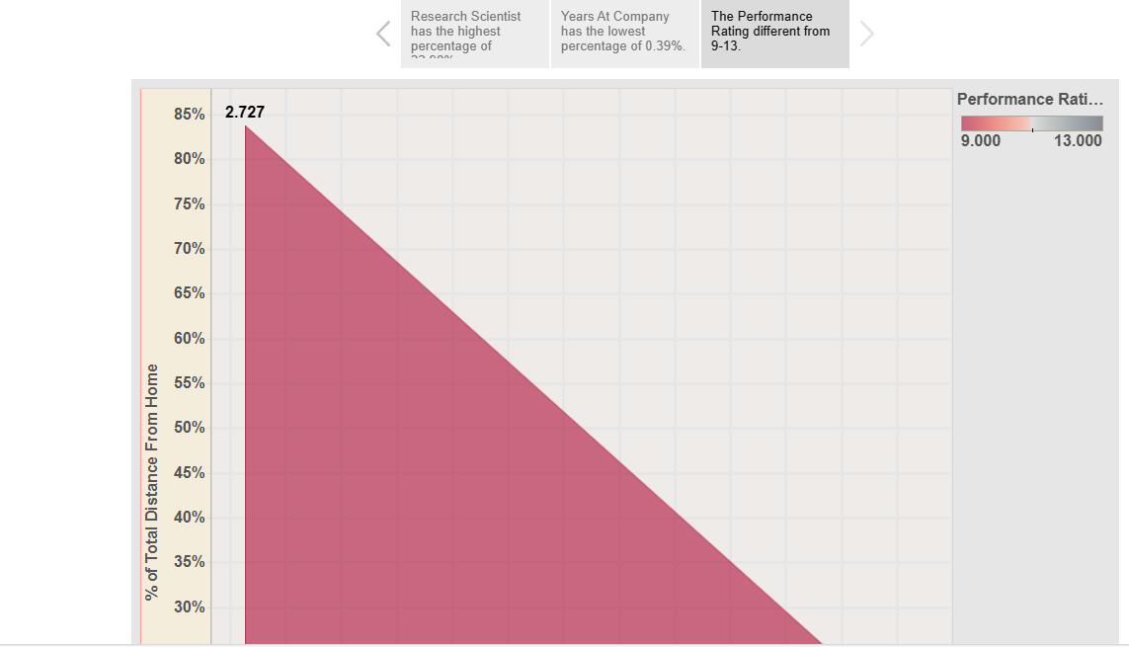

**APPENDIX:**

**Empathy Map & Brainstorming link**

[**https://github.com/9384396589/MEASURING--SUCCESS--IN--TALENT--MEASURING-_-NM2023TMID08431.git**](https://github.com/9384396589/MEASURING--SUCCESS--IN--TALENT--MEASURING-_-NM2023TMID08431.git)

**Dash Board link**

[**https://public.tableau.com/views/HRScorecardMeasuringSuccessInTalentManagement/Dashboard1?:language=en-US&publish=yes&:display_count=n&:origin=viz_share_link**](https://public.tableau.com/views/HRScorecardMeasuringSuccessInTalentManagement/Dashboard1?:language=en-US&publish=yes&:display_count=n&:origin=viz_share_link)

**Story link**

[**https://public.tableau.com/views/HRScorecardMeasuringSuccessInTalentManagement/Story1?:language=en-US&publish=yes&:display_count=n&:origin=viz_share_link**](https://public.tableau.com/views/HRScorecardMeasuringSuccessInTalentManagement/Story1?:language=en-US&publish=yes&:display_count=n&:origin=viz_share_link)

**Dash Board 2**

[**https://public.tableau.com/app/profile/m.sangeetha/viz/DashBoard2_16954457736680/Dashboard2?publish=yes**](https://public.tableau.com/app/profile/m.sangeetha/viz/DashBoard2_16954457736680/Dashboard2?publish=yes)

**Dash Board 3**

[**https://public.tableau.com/app/profile/m.sangeetha/viz/DashBoard3_16954461641680/Dashboard3?publish=yes**](https://public.tableau.com/app/profile/m.sangeetha/viz/DashBoard3_16954461641680/Dashboard3?publish=yes)

**Dash Board 4**

**https://public.tableau.com/app/profile/m.sangeetha/viz/DashBoard4_16954464522010/DashBoard4?publish=yes**

**Story 2 link**

[**https://public.tableau.com/app/profile/m.sangeetha/viz/Story2_16953985137340/Story2?publish=yes**](https://public.tableau.com/app/profile/m.sangeetha/viz/Story2_16953985137340/Story2?publish=yes)